**STUDY THE DATASHEET OF 16X2 LCD**

Youtube Video [Link](https://youtu.be/cXpeTxC3_A4?si=hmP6AzY6bXShpAtQ)

|  |
| --- |
|  |

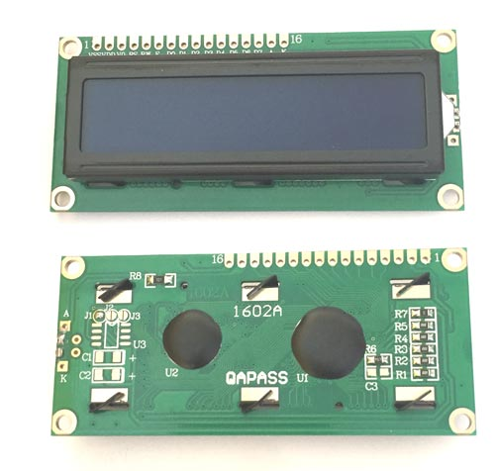

**Liquid Crystal Displays (LCDs)**

***1. Introduction:***

* LCDs are flat-panel displays widely used in electronic devices for visual output.
* They utilize the properties of liquid crystals to control the passage of light, enabling the display of text, numbers, and graphics.

***2. Functions & Features:***

* Display text, numbers, and graphical patterns.
* Low power consumption.
* Lightweight and compact.
* Can operate in a wide range of temperatures.
* Suitable for both indoor and outdoor applications.
* Can be interfaced with microcontrollers and other digital devices for visual output.

***3. Mechanism:***

* LCDs consist of liquid crystal cells sandwiched between two polarizing sheets.
* The liquid crystal cells change orientation when subjected to an electric field, controlling the passage of light through the display.
* By selectively applying voltage to specific segments of the display, characters, numbers, or graphics can be formed.

***4. Pins Description:***

* LCD modules typically have multiple pins for power, data, and control signals.
* Common pins include VCC (power supply), GND (ground), RS (Register Select), RW (Read/Write), EN (Enable), and data pins for sending commands and data to the display.

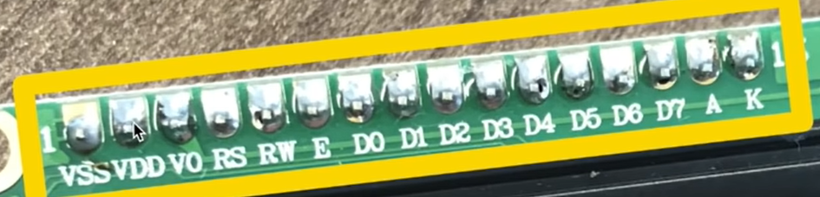

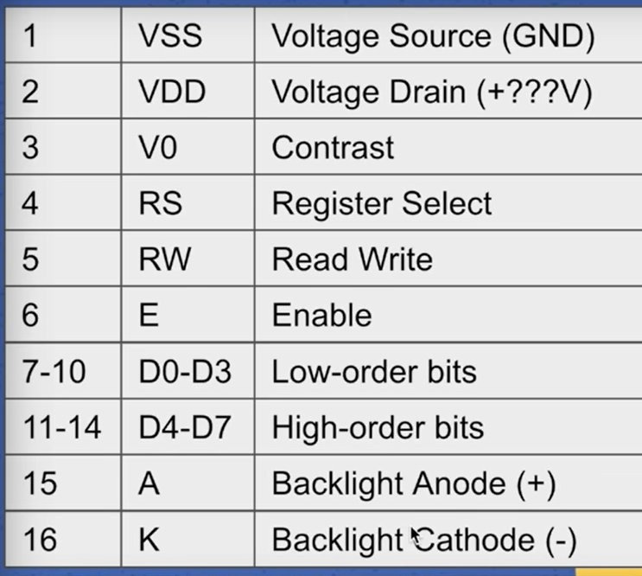

***5. Electrical Characteristics:***

* Operating Voltage: Typically 5V or 3.3V.
* Operating Current: Depends on the display size and backlight configuration.
* Interface: Parallel or serial communication with microcontrollers.
* Backlight: Some LCDs feature built-in LED backlighting for enhanced visibility in low-light conditions.

***6. Quality Specifications:***

* + Resolution: Defines the number of pixels or characters that can be displayed.
  + Contrast Ratio: The ratio of the luminance of the brightest color to that of the darkest color the system is capable of producing.
  + Response Time: The time taken for a pixel to transition from one state to another.
  + Viewing Angle: The maximum angle at which the display can be viewed with acceptable visual performance.
  + MTBF (Mean Time Between Failures): A measure of the expected reliability of the display module.

***7. Other Important Considerations:***

* + Compatibility: Ensure compatibility between the LCD module and the interfacing device (e.g., microcontroller).
  + Programming: Write code to control the LCD and send commands/data for displaying desired content.
  + Environmental Conditions: Consider operating temperature, humidity, and other environmental factors when selecting an LCD for a specific application.
  + Mounting and Enclosure: Provide appropriate mounting and enclosure to protect the LCD from physical damage and environmental hazards.

In summary, LCD displays are versatile visual output devices suitable for a wide range of applications. Understanding their functions, features, mechanism, pin descriptions, electrical characteristics, quality specifications, and other important considerations is essential for effectively integrating them into electronic projects and systems.

**Guide to Connecting and Using an LCD with an 8051 Microcontroller**

Sure! Here’s a step-by-step explanation of how to connect an LCD to a microcontroller (such as the 8051) and print characters on it:

**1. Understand the LCD Pins**

A typical 16x2 LCD has 16 pins, but the most important ones are:

* **VSS**: Ground
* **VDD**: Power supply (typically +5V)
* **VO**: Contrast adjustment
* **RS**: Register Select (0 for command, 1 for data)
* **RW**: Read/Write (0 for write, 1 for read)
* **E**: Enable
* **D0-D7**: Data pins
* **A and K**: Backlight (Anode and Cathode)

**2. Connect Power and Contrast**

* Connect **VSS** to ground.
* Connect **VDD** to +5V.
* Connect **VO** to a potentiometer (middle pin) to adjust the display contrast.

**3. Connect Control Pins**

* Connect the **RS**, **RW**, and **E** pins to three GPIO pins on the microcontroller.
  + For example, RS to P2.0, RW to P2.1, and E to P2.2 on an 8051 microcontroller.

**4. Connect Data Pins**

* For 4-bit mode (commonly used to save GPIO pins):
  + Connect only the higher four data pins (D4-D7) to four GPIO pins on the microcontroller.
  + For example, D4 to P2.4, D5 to P2.5, D6 to P2.6, and D7 to P2.7.
* For 8-bit mode:
  + Connect all eight data pins (D0-D7) to eight GPIO pins on the microcontroller.

**5. Initialize the LCD**

Initialization involves sending a series of commands to the LCD to set it up. Here’s the sequence:

1. **Power on delay**: Wait for the LCD to become ready (typically 20ms).
2. **Function set**: Send the command to set 4-bit mode, number of lines, and character font.
3. **Display control**: Turn on the display and set cursor and blinking options.
4. **Entry mode set**: Set the cursor move direction (increment) and display shift.
5. **Clear display**: Clear the display and move the cursor to the home position.

**6. Send Commands and Data**

* **Command Mode**: Set RS to 0, RW to 0, place the command on the data pins, and pulse the E pin.
* **Data Mode**: Set RS to 1, RW to 0, place the character data on the data pins, and pulse the E pin.

**7. Print Characters**

* To print characters, send the character data in ASCII format to the LCD in data mode.

**Example Steps for Initialization and Printing:**

1. **Initialization Sequence** (in 4-bit mode):
   * Send 0x02 to initialize the LCD in 4-bit mode.
   * Send 0x28 for 2-line display, 5x8 font.
   * Send 0x0C to turn on the display and turn off the cursor.
   * Send 0x06 to set entry mode (increment cursor, no display shift).
   * Send 0x01 to clear the display.
2. **Sending Data to Display 'HELLO'**:
   * Set RS to 1 (data mode).
   * Send ASCII values for 'H', 'E', 'L', 'L', 'O' sequentially.

**Summary of Connections:**

* **Power**:
  + VSS to GND
  + VDD to +5V
  + VO to potentiometer (contrast control)
* **Control Pins**:
  + RS to P2.0
  + RW to P2.1
  + E to P2.2
* **Data Pins (for 4-bit mode)**:
  + D4 to P2.4
  + D5 to P2.5
  + D6 to P2.6
  + D7 to P2.7

**Summary of Commands:**

* **Initialization**:
  + 0x02: 4-bit mode initialization
  + 0x28: 4-bit mode, 2 lines, 5x8 font
  + 0x0C: Display ON, cursor OFF
  + 0x06: Entry mode set
  + 0x01: Clear display
* **Printing 'HELLO'**:
  + ASCII values: 'H' (0x48), 'E' (0x45), 'L' (0x4C), 'L' (0x4C), 'O' (0x4F)

By following these steps and understanding the sequence of commands, you can connect an LCD to an 8051 microcontroller and display characters on it.

**LCD 1602h to MCU:**

|  |
| --- |
| C:\Users\lenovo\AppData\Local\Packages\Microsoft.Windows.Photos_8wekyb3d8bbwe\TempState\ShareServiceTempFolder\LCD Pins.jpeg |

**As in the below diagram, it is shown that LCD data/commands pins are connected to the MCU Port 0.**

|  |
| --- |
| C:\Users\lenovo\AppData\Local\Packages\Microsoft.Windows.Photos_8wekyb3d8bbwe\TempState\ShareServiceTempFolder\LCD data Pins to MCU Port_0.jpeg |

|  |
| --- |
| **C:\Users\lenovo\OneDrive\Desktop\TASKS_STC_89C52-RC\TASK_14\TASK_14_03\LCD_pin (RW).jpg** |

|  |
| --- |
| C:\Users\lenovo\OneDrive\Desktop\TASKS_STC_89C52-RC\TASK_14\TASK_14_03\LCD Commands.jpg |

|  |
| --- |
| C:\Users\lenovo\OneDrive\Desktop\TASKS_STC_89C52-RC\TASK_14\TASK_14_03\LCD_pin (RW).jpg |